*The way to require financial data and plot trend figure*

Hushrush.2021.05.16

*Read the original article on the page below.*

[*https://towardsdatascience.com/in-12-minutes-stocks-analysis-with-pandas-and-scikit-learn-a8d8a7b50ee7*](https://towardsdatascience.com/in-12-minutes-stocks-analysis-with-pandas-and-scikit-learn-a8d8a7b50ee7)

1. Create a python file with Jupyter Notebook

I have to use Jupyter Notebook due to the requirement of the Professor. To create a python file with Jupyter Notebook, you have to install Anaconda previously. Open the Anaconda Navigator and choose Jupyter Notebook as figure 1.1.

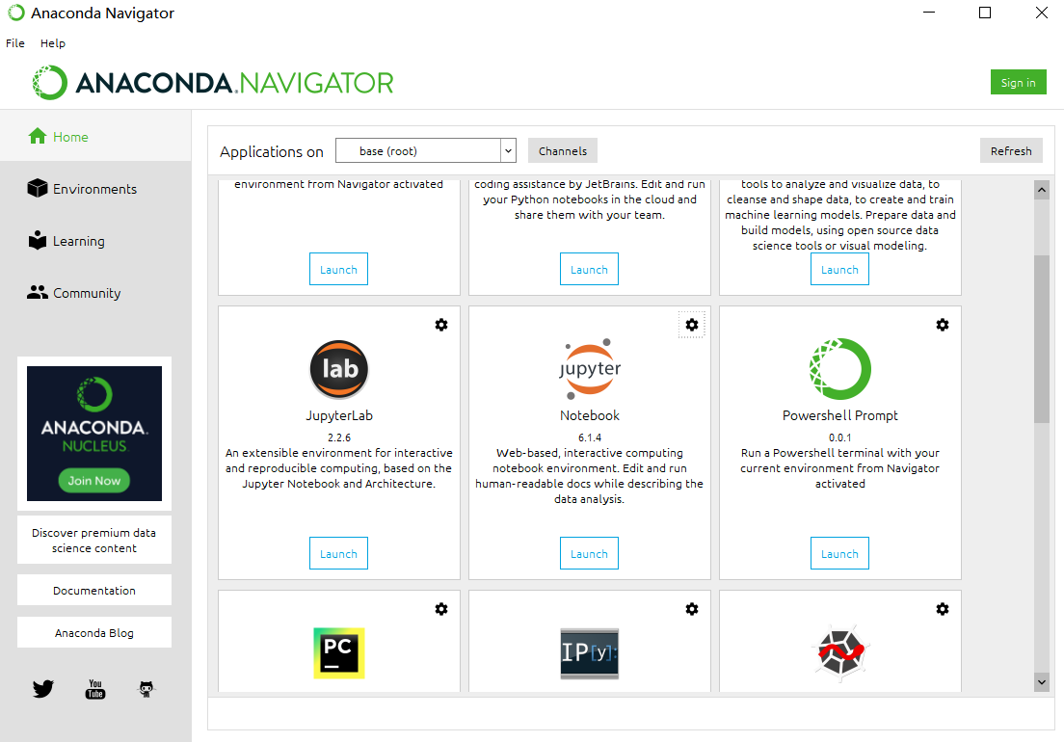

Figure 1.1 Choose Jupyter Notebook

Create a folder and a new python file through ”new” button on the left of the top as figure 1.2.

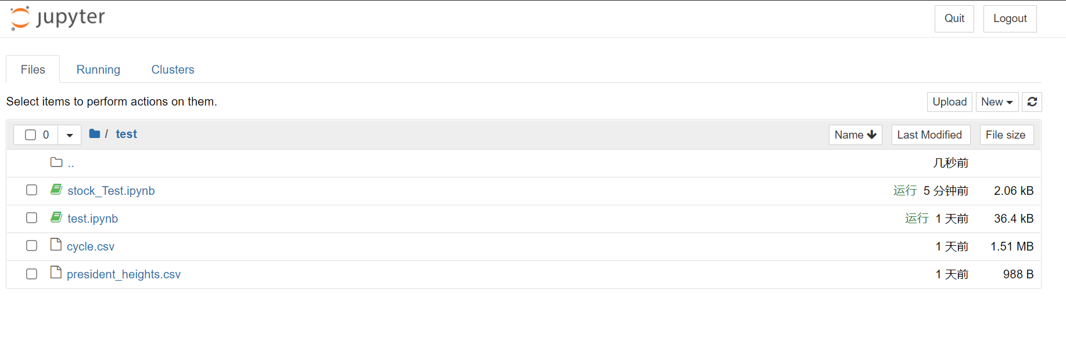

Figure 1.2 create a new folder and python file

1. Loading YahooFinance Dataset with Pandas Web Data Reader

Pandas web data reader is able to acquire financial data from Yahoo finance, Google finance[1] and Enigma,etc. Type code below:

import pandas as pd

import datetime

import pandas_datareader.data as web

from pandas import Series, DataFrame

start = datetime.datetime(2010, 1, 1)

end = datetime.datetime(2017, 1, 11)

df = web.DataReader("AAPL", 'yahoo', start, end)

df.tail()

However I encountered an error as figure 2.1.

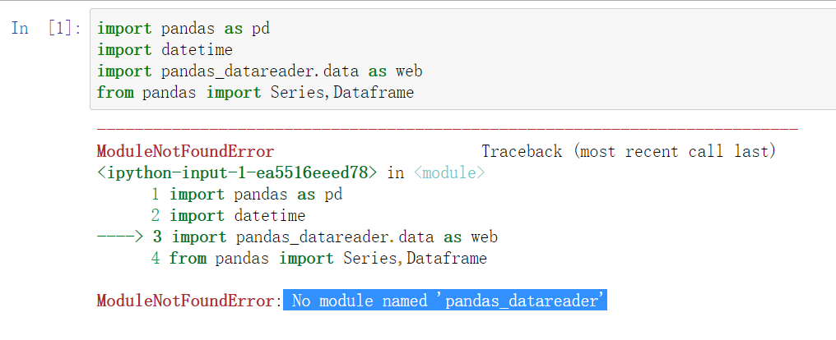

Figure 2.1 An error

This is because I haven’t installed pandas_datareader and DataFrame. Just type “pip install pandas-datareader” in the code box and it will install it. Another thing to be noticed is that it is “DataFrame” rather than “Dataframe”.

After revising codes, I successfully acquired financial data in a table as figure 2.2.

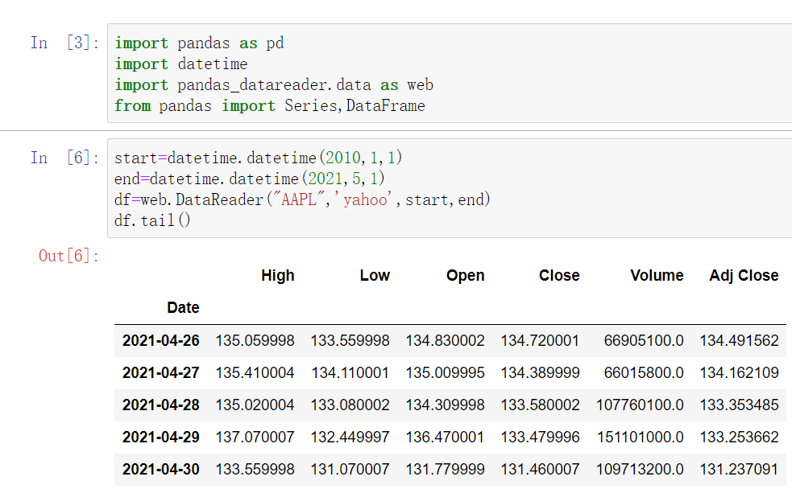

Figure 2.2 Some data

Closing Price will be used as final price for stocks and it represents price in which the stocks are traded by the end of the day.

1. Rolling Mean(Moving Average)-to determine trend

A powerful tool to smooth data and cut down noise in chart is Rolling Mean/Moving Average (MA)[2]. It creates a constantly updated average price. It also plays the role of resistance to the moving trend, namely downtrend and uptrend will be less likely to deviate outside the resistance point.

Code out the rolling mean and plot out with Matplotlib

%matplotlib inline  
import matplotlib.pyplot as plt  
from matplotlib import style  
# Adjusting the size of matplotlibimport matplotlib as mpl  
mpl.rc('figure', figsize=(8, 7))  
mpl.__version__  
# Adjusting the style of matplotlibstyle.use('ggplot')  
close_px.plot(label='AAPL')  
mavg.plot(label='mavg')  
plt.legend()

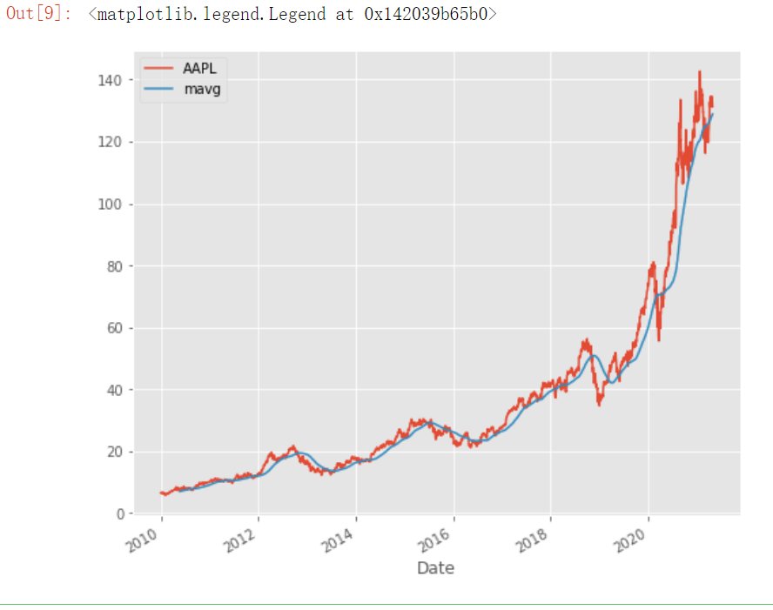

Figure 3.1 Plot of the stock price of AAPL

The mean average significantly smoothed the line and it is clear that Apple’s stock price has kept rising through last 11 years.

1. No longer support Google finance.
2. Also can refer to https://blog.csdn.net/xxzhangx/article/details/76938053